Veterinary Consent Form
Harriet Winstanley Mobile: 07427305215 Email: hairytailvetphysio@gmail.com
- Physiotherapy has been requested for the patient, by the owner/ client
- Patient has been referred for physiotherapy
Patient Details
Species | Horse Dog Other
Name |  |  | Age
Sex: |  | Breed:
Client Details
Name
Contact Number
Email
Address
Veterinary Practice
Vet name
Practice Address
Presenting condition
Current medication
Special Instruction
If possible please send medical history to hairytailvetphysio@gmail.com
I consent to the above animal receiving physiotherapy treatment.
Veterinarian Name:
Sign:
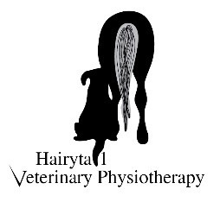
Date:

